VIETNAM GENERAL CONFEDERATION OF LABOUR

**TON DUC THANG UNIVERSITY**

**FACULTY OF INFORMATION TECHNOLOGY**



**Huỳnh Vũ Minh Hiếu – 522H0024**

**Nguyễn Đình Việt Hoàng - 522H0120**

**Hoàng Văn Minh – 522H0020**

**Ngô Trung Tiến – 522H0040**

**FLOWER SHOP MANAGEMENT SYSTEM**

**FINAL REPORT**

**REQUIREMENTS ANALYSIS AND DESIGN**

**HO CHI MINH CITY, YEAR 2024**

VIETNAM GENERAL CONFEDERATION OF LABOUR

**TON DUC THANG UNIVERSITY**

**FACULTY OF INFORMATION TECHNOLOGY**



**Huỳnh Vũ Minh Hiếu – 522H0024**

**Nguyễn Đình Việt Hoàng - 522H0120**

**Hoàng Văn Minh – 522H0020**

**Ngô Trung Tiến – 522H0040**

**FLOWER SHOP MANAGEMENT SYSTEM**

**FINAL REPORT**

**REQUIREMENTS ANALYSIS AND DESIGN**

**Instructor**

**Ms. Hồ Thị Thanh Tuyến**

**HO CHI MINH CITY, YEAR 2024**

**LIST OF MEMBERS**

|  |  |  |  |  |
| --- | --- | --- | --- | --- |
| **STT** | **MSSV** | **Full Name** | **Evaluate (%)** | **Note** |
| 1 | 522H0120 | Nguyễn Đình Việt Hoàng | 100% | Leader |
| 2 | 522H0040 | Ngô Trung Tiến | 100% |  |
| 3 | 522H0020 | Hoàng Văn Minh | 100% |  |
| 4 | 522H0024 | Huỳnh Vũ Minh Hiếu | 100% |  |

**ACKNOWLEDGEMENT**

We sincerely thank Ms. Hồ Thị Thanh Tuyến for teaching us the Requirements Analysis and Design course with great enthusiasm. We want to express our deep appreciation for the dedication and professional knowledge that you shared with us. Through your classes, we gained a better understanding of the fundamental aspects of the Requirements Analysis and Design, thanks to your detailed explanations and practical applications. You helped us grasp the knowledge and apply it effectively. Finally, we extend our heartfelt gratitude to Ms. Hồ Thị Thanh Tuyến for your commitment and invaluable support throughout our learning journey in this course. The skills and knowledge we acquired will continue to impact our future development. We sincerely thank you and wish your health, success, and happiness.

*Ho Chi Minh City, May 2, 2024*

*Authors:*

*Huỳnh Vũ Minh Hiếu*

*Nguyễn Đình Việt Hoàng*

*Hoàng Văn Minh*

*Ngô Trung Tiến*

**THE COMPLETION REPORT HAS BEEN SUBMITTED AT TON DUC THANG UNIVERSITY**

Our group assures that this is our own report and was guided by Ms. Hồ Thị Thanh Tuyến. The research content and results in this report are honest and have not been published in any form before. The figures in the tables used for analysis, comments, and evaluations were collected by the authors from various sources clearly stated in the reference section.

Additionally, the report includes some comments, evaluations, and data from other authors and organizations, all of which are cited and noted for their origin.

**If any fraud is detected, we fully take responsibility for the content of our final report for the second semester of the 2023-2024 academic year.** Ton Duc Thang University is not involved in any copyright or intellectual property violations that we may cause during the process (if any).

*Ho Chi Minh City, May 2, 2024*

*Authors:*

*Huỳnh Vũ Minh Hiếu*

*Nguyễn Đình Việt Hoàng*

*Hoàng Văn Minh*

*Ngô Trung Tiến*

**INSTRUCTOR RUBRIC**

Supervisor’s Name: ……………………………………………………………..............

Comments: ……………………………………………………………………………...

Total Score Based on Rubric Evaluation: ………………………………………………

*Ho Chi Minh City, date … month … year …*

*Supervisor*

*(sign and write your full name)*

**TABLE OF CONTENTS**

LIST OF IMAGES 15

PART 1: SYSTEM OVERVIEW 18

1.1. System Introduction: 18

1.2. Objectives: The objectives of developing the flower shop management system are as follows: 18

1.3. Scope: The flower shop management system focuses on the following entities: 19

a. Service users (customers): 19

b. Flower shop staff: 19

c. Suppliers: 19

d. Business partners: 20

PART 2: IDENTIFY AND ANALYZE REQUIREMENTS 20

2.1. Interviews: 20

**2.1.1. Interview Plan Overview:** 20

*Table 2.1.1. Interview plan overview* 20

**2.1.2. Detailed interview plan:** 21

*Table 2.1.2. Detailed interview plan* 22

2.2. Status analysis: 27

**2.2.1. Current state of organization:** 27

**2.2.3. Advantages of the system:** 30

a. For customers: 30

b. For system employees: 30

**2.2.4. Some issues with the current system:** 31

a. Slowness: 31

b. Difficulty in searching: 31

c. Overload: 31

d. Prone to errors: 31

2.3. General system requirements: 32

**2.3.1. Mandatory basic requirements:** 32

**2.3.2. For system employees:** 32

**2.3.3. For management:** 32

**2.3.4. For the system:** 33

2.4. Suggest some possible features for the flower shop management system: 33

PART 3: SYSTEM REQUIREMENTS SPECIFICATION 34

3.1. Requirements specification: 34

*Table 3.1. Requirements specification* 34

**3.1.1. Functional Requirements:** 34

3.1.1.1. For Customers: 34

3.1.1.2. For Management Staff: 35

**3.1.2. Non-Functional Requirements:** 35

3.1.2.1. Performance: 35

3.1.2.2. Backup: 36

3.1.2.3. Accessibility: 36

3.1.2.4. Security: 36

3.1.2.5. Compatibility: 36

3.1.2.6. Maintainability: 36

3.1.2.7. Convertibility: 37

3.2. Feasibility assessment: 37

*Table 3.2. Feasibility assessment* 37

PART 4: SYSTEM ANALYSIS AND DESIGN 39

4.1. Requirements Analysis: 39

**4.1.1. Functional modeling:** 39

4.1.1.1. General Use Case Diagram: 39

4.1.1.2. Login function: 39

4.1.1.2.1 Use Case Login: 39

4.1.1.2.2 Functional Specification: 40

4.1.1.2.3 Activity Login: 41

4.1.1.3. Make Register function: 42

4.1.1.3.1 Use Case Register: 42

4.1.1.3.2 Functional Specification: 43

4.1.1.3.3 Activity Register: 44

4.1.1.4. Make Order function: 45

4.1.1.4.1 Use Case Make Order: 45

4.1.1.4.2 Functional Specification: 46

4.1.1.4.3 Activity Make Order: 47

4.1.1.5. Search Products function: 48

4.1.1.5.1 Use Case Search Products: 48

4.1.1.5.2 Functional Specification: 48

4.1.1.5.3 Activity Search Products: 50

4.1.1.6. Manage Products function: 51

4.1.1.6.1 Use Case Manage Products: 51

4.1.1.6.2 Functional Specification: 51

4.1.1.6.3 Activity Manage Products: 53

4.1.1.7 Make Delivery function: 54

4.1.1.7.1 Use Case Make Delivery: 54

4.1.1.7.2 Functional Specification: 54

4.1.1.7.3 Activity Make Delivery: 56

4.1.1.8 Manage Employees function: 57

4.1.1.8.1 Use Case Manage Employees: 57

4.1.1.8.2 Functional Specification: 57

4.1.1.8.3 Activity Manage Employees: 59

4.1.1.9. Manage Customers function: 60

4.1.1.9.1 Use Case Manage Customers: 60

4.1.1.9.2 Functional Specification: 61

4.1.1.9.3 Activity Manage Customers: 62

4.1.1.10. Manage Orders function: 63

4.1.1.10.1 Use Case Manage Orders: 63

4.1.1.10.2 Functional Specification: 63

4.1.1.10.3 Activity Manage Orders: 65

4.1.1.11. Manage Stocks function: 66

4.1.1.11.1 Use Case Manage Stocks: 66

4.1.1.11.2 Functional Specification: 66

4.1.1.12. Report Statistics function: 69

4.1.1.12.1 Use Case Report Statistics: 69

4.1.1.12.2 Functional Specification: 70

4.1.1.12.3 Activity Report Statistics: 71

**4.1.2. Behavioral modeling:** 72

4.1.2.1 Login: 72

**4.1.3. Structural modeling:** 83

**4.1.4. Data modeling:** 83

4.2. System Design: 89

**4.2.1. Database design:** 89

**4.2.2. Interface design:** 97

• Login: 97

• Register: 98

• Private information page: 99

• Home page: 99

• Manage products: 100

• Manage orders: 101

PART 5: EVALUATION AND CONCLUSION 101

5.1. Advantages: 101

5.2. Difficulties: 101

5.3. Lessons: 102

REFERENCES 103

# LIST OF IMAGES

Image 4. 1: General Use Case…………………………………………………………………………..34

Image 4. 2: Use Case Login…………………………………………………………………………….34

Image 4. 3: Activity Login……………………………………………………………………………...36

Image 4. 4: Use Case Register………………………………………………………………………….37

Image 4. 5: Activity Register…………………………………………………………………………...39

Image 4. 6: Use Case Make Order……………………………………………………………………...40

Image 4. 7: Activity Make Order……………………………………………………………………….42

Image 4. 8: Use Case Search Products…………………………………………………………………43

Image 4. 9: Activity Search Product…………………………………………………………………… 45

Image 4. 10: Use Case Manage Products………………………………………………………………46

Image 4. 11: Activity Manage Products………………………………………………………………..48

Image 4. 12: Use Case Make Delivery…………………………………………………………………49

Image 4. 13: Activity Make Delivery…………………………………………………………………..51

Image 4. 14: Use Case Manage Employees…………………………………………………………….52

Image 4. 15: Activity Manage Employees……………………………………………………………..54

Image 4. 16: Use Case Manage Customers…………………………………………………………….55

Image 4. 17: Activity Manage Customers……………………………………………………………...57

Image 4. 18: Use Case Manage Orders………………………………………………………………...58

Image 4. 19: Activity Manage Orders………………………………………………………………….60

Image 4. 20: Use Case Manage Stocks…………………………………………………………………61

Image 4. 21: Activity Manage Stocks…………………………………………………………………..63

Image 4. 22: Use Case Report Statistics………………………………………………………………..64

Image 4. 22: Activity Report Statistics…………………………………………………………………66

Image 4. 23: Sequence Diagram Login………………………………………………………………...67

Image 4. 24: Sequence Diagram Register………………………………………………………………68

Image 4. 25: Sequence Diagram Make Order………………………………………………………….69

Image 4. 26: Sequence Diagram Search Products……………………………………………………...70

Image 4. 27: Sequence Diagram Manage Products…………………………………………………….71

Image 4. 28: Sequence Diagram Make Delivery……………………………………………………….72

Image 4. 29: Sequence Diagram Manage Employees………………………………………………….73

Image 4. 30: Sequence Diagram Manage Customers…………………………………………………..74

Image 4. 31: Sequence Diagram Manage Orders………………………………………………………75

Image 4. 32: Sequence Diagram Manage Stocks………………………………………………………76

Image 4. 33: Sequence Diagram Report Statistics……………………………………………………...77

Image 4. 34: Class Diagram…………………………………………………………………………….78

Image 4. 35: ERD Model……………………………………………………………………………….83

Image 4. 36: Database Model…………………………………………………………………………..84

**LIST OF TABLES**

*Table 3.1. Requirements specification 16*

*Table 3.2. Feasibility assessment* 19

# PART 1: SYSTEM OVERVIEW

## 1.1. System Introduction:

+ The flower shop management system is a system developed to manage the business operations in a flower shop. Currently, managing a flower shop involves various challenges, including selecting and purchasing flowers from suppliers, managing inventory, scheduling deliveries, and maintaining customer information.

+ The flower shop management system aims to address these challenges by automating management processes, enhancing inventory management capabilities, managing customer information, and providing statistical reports to support business decision-making.

## 1.2. Objectives: The objectives of developing the flower shop management system are as follows:

* Manage the process of flower information input and output, including selecting and purchasing flowers from suppliers, managing inventory, and monitoring stock levels.
* Manage customer information, including storing personal information, purchase history, and customer preferences.
* Create delivery schedules and manage customer orders.
* Provide statistical reports on revenue, inventory, and business activities.
* Integrate online ordering functionality to allow customers to place flower orders online and track order status.

## 1.3. Scope: The flower shop management system focuses on the following entities:

#### a. Service users (customers):

* Customers can access the system to view and place orders online, manage personal information, and review purchase history.

#### b. Flower shop staff:

* Store managers: They have access to and manage all information related to the flower shop, including the list of flower products, customer information, inventory, and orders.
* Sales staff: They receive and process orders from customers, create delivery schedules, and update order status.
* Inventory managers: They manage the process of receiving and distributing goods, perform inventory checks, and update information on quantity and status of flower products.
* Customer information managers: They manage customer personal information, purchase history, and preferences to create better promotional programs and services.
* Delivery personnel: They manage delivery schedules and update delivery status for customers.

#### c. Suppliers:

* Flower suppliers can provide information about flower products, prices, and availability.

#### d. Business partners:

* Business partners in the flower advertising and promotion field can be integrated into the system to provide information about promotional programs and special events related to the flower shop.

# PART 2: IDENTIFY AND ANALYZE REQUIREMENTS

# 2.1. Interviews:

### **2.1.1. Interview Plan Overview:**

##### *Table 2.1.1. Interview plan overview*

|  |  |  |  |  |
| --- | --- | --- | --- | --- |
| **Interview Plan Overview**  System: Flower Shop Management  Prepared by: Nguyễn Đình Việt Hoàng  Date: 9/4/2024 | | | | |
| Sequence numbers | Subjects | Requirements | Start dates | End dates |
| 1 | Product Management | + Understand the process of receiving, preserving, and arranging various types of flowers.  + Know how to contact and order from flower suppliers.  + Manage inventory and ensure a diverse product range for customers. | 8/4/2024 | 11/4/2024 |
| 2 | Promotion Strategy | + Develop promotional programs (discounts, gifts) to attract and retain customers.  + Update information and news about new flowers, special events. | 8/4/2024 | 11/4/2024 |
| 3 | Customer Management | + Store and analyze customer information to improve service.  + Accumulate points and upgrade membership cards based on purchase levels. | 8/4/2024 | 11/4/2024 |
| 4 | Statistical Reports | + Conduct sales reports, accompanying services.  + Evaluate business performance over specific periods. | 12/4/2024 | 14/4/2024 |
| 5 | System and Software | + Assess and upgrade machinery and software to optimize workflows.  + Perform regular maintenance and repair equipment when necessary. | 12/4/2024 | 14/4/2024 |

### **2.1.2. Detailed interview plan:**

##### *Table 2.1.2. Detailed interview plan*

|  |  |
| --- | --- |
| **Detailed interview plan**  System: Flower Shop Management | |
| *Interviewee:*  Trần Bỉnh Quyền | *Analyst:*  Nguyễn Đình Việt Hoàng  Ngô Trung Tiến |
| *Location/Medium:*  In-person interview at school (using phones) | *Time:*   * Start: 8h 12/4/2024 * End: 11h 12/4/2024 |
| *Target:*  Collect information from customers to better understand the operating process of the system. | Note: |
| *Interview details:*   * Introduction * Overview of the system * Subject 1: Flowers management process. * Subject 2: News and promotion planning process. * Subject 3: Customer management process. * Subject 4: Statistical and reporting process. * Subject 5: Machinery and software systems. * Key point summary * End | Estimated time: |
| Overview observations and unexpected occurrences | Confident attitude, relaxed response, positive feedback |

|  |  |  |
| --- | --- | --- |
| *Interviewee:*  Trần Bỉnh Quyền | | *Date:* 12/4/2024 |
| *Questions* | | *Answers* |
| Subject 1 | Question 1: How is the flower search process performed? | Answer: The Management Department will conduct a survey and select existing flowers. After that, information about these flowers will be presented to the Board of Directors. Based on the judgment and decision of the Board of Directors, representatives of the store will contact the distributor or intermediary companies that own the flower garden directly to purchase flowers. This process helps ensure that the store always has popular flowers available and tailored to the needs of customers. |
| Question 2: What is the allocation of flowers for each region with climatic conditions? | Answer: The distribution of flowers must be based on the suitability of each type of flower to the climatic conditions of the region. Typically, flowers that can thrive in the specific climate of a region are chosen. This ensures that the flowers can grow healthily and bloom fully. For instance, in a region with a hot and dry climate, drought-tolerant flowers like succulents or sunflowers might be chosen. In contrast, in a region with a cool and wet climate, flowers like hydrangeas or ferns that prefer cooler temperatures and higher humidity might be more suitable. |
| Question 3: How long is the interval between flowers that need to be watered? | Answer: The watering schedule for different types of flowers can vary depending on several factors such as the type of flower, environmental conditions, and soil type. Here are some general guidelines:   * **Succulents and Cacti**: These plants are suited to dry environments and require minimal watering. * **Tropical Plants**: Such as Monstera or Philodendron, require consistent moisture. * **Ferns**: Prefer a moist environment, therefore they need to be watered more frequently. * **Orchids**: Have unique watering requirements. * **Air Plants (Tillandsia)**: Need to be misted or soaked, usually once or twice a week.   A general rule is that most types of flowers need about one inch (2.5 cm) of water per week. However, this can vary depending on weather conditions and soil type. For instance, in hot weather or fast-draining soil, you might need to water daily. To know exactly when to water, you can check the soil’s moisture by sticking your finger into the soil near the plant’s base. If the top layer of soil feels dry, it’s a sign that you need to water. Remember, each type of flower has different water requirements, so it’s important to consider the specific needs of each type of flower. |
| Subject 2 | Question 1: Do promotions focus primarily on individual flower discounts or individual pots? | Answer: Not necessarily. Promotions can focus on a variety of objectives, not just discounts for individual flowers or individual pots. For example, a store could create promotions for bouquets, pre-made flower arrangements, or even services like free delivery. In addition, the store could also create promotions based on seasons or special events. The main goal is to attract and retain customers, increase sales, and optimize profits. Each store will have its own promotional strategy based on the needs of its customers and its business objectives. |
| Question 2: How should flower news be updated to attract customers to visit and buy? | Answer: To attract customers to visit and shop, flower news needs to be updated in the following ways:   * **Engaging Content**: Use visually appealing flower imagery on social media platforms. Share tips, tricks, and recommendations related to flower arrangement, plant care, or event planning to engage users and build a loyal community. * **Unique Promotions**: Everyone loves a good deal. Having a unique weekly promotion is a perfect way to draw attention to your store and flower products. * **Frequent Updates**: News should be regularly updated, especially regarding new flower varieties, special events, or promotional programs. * **Leverage Technology**: Use technology to optimize customer outreach. For example, you can use online advertising on Google, Bing, Yandex, or Baidu; social media advertising on Instagram, Twitter, Facebook, and LinkedIn; or search engine optimization (SEO) for your website. * **Educational Content**: Use your blog to educate customers and you will turn them into buyers |
| Subject 3 | Question 1: How to earn points for customers with membership cards and how to upgrade categories? | Answer: The system will be based on the accumulated score of customers in 1 year of in-store purchases and will upgrade the corresponding card for customers next year. The accumulated point increase will be based on the bill the customer has paid for the purchase. Specifically, for every 10000 VND, customers accumulate 1 point. |
| Question 2: If a customer forgets their membership card when making a purchase, can they earn points? | Answer: In order to accumulate points and use points to pay for transactions at the store, customers in addition to using membership cards can log into their accounts on the online system to be able to accumulate points. |
| Subject 4 | Question 1: What items does the system need? | Answer:  + The system needs statistics:  - Statistics on the number of flowers sold for each type of flower.  - Statistics of accompanying items such as pots, shovels, etc.  - Statistics of the total revenue of the whole store at the specified time period. |
| Subject 5 | Question 1: How long is the periodic inspection of the store's equipment carried out? | Answer: The inspection of the store's equipment is carried out after about every 1 year. This ensures that the equipment is functioning properly and safely, and any necessary maintenance or repairs can be identified and addressed promptly. It's important to note that more frequent inspections might be necessary for certain types of equipment or under certain conditions. |
| Question 2: When a flower area in the store has an error problem, how should it be handled? | Answer: When a flower area in the store encounters a problem, it should be handled in the following steps:   1. **Identify the problem**: First, clearly identify the issue at hand. It could be a problem with the watering system, lighting system, or it could be a sign of pest infestation. 2. **Assess the severity**: Next, assess the severity of the problem. This will help determine whether the issue can be resolved immediately or if professional help is needed. 3. **Implement a solution**: Based on the severity of the problem, implement an appropriate solution. This could involve repairing the watering or lighting system, moving plants to a different area of the store, or applying pest control measures. 4. **Check again**: After implementing the solution, check again to ensure that the problem has been completely resolved. If not, additional steps may need to be taken. 5. **Prevention**: Finally, consider implementing preventive measures to prevent similar problems from occurring in the future. This could involve improving the watering or lighting system, changing the arrangement of plants, or implementing regular pest control measures. |
| Question 3: How is the upgrade and maintenance of the flower shop system done? | Answer: Every 6 months, the system will be maintained 1 time to upgrade the system more optimally, add new features to meet customer needs as well as fix problems that cause errors during the user's use of the system. |

## 2.2. Status analysis:

### **2.2.1. Current state of organization:**

**2.2.2. Management steps in the system:**

Board of Directors

Flower shop Hồng Loan

Technical & Maintenance Department

Accounting Department

Marketing & Advertising Department

Sales Management Department

Staff Management Department

Store Space Management Department

Product Management Department

*Step 1: Research and select new types of flowers*

* The flower management department conducts research and learns about new types of flowers available in the market. Based on the current demand and trends, they choose suitable types of flowers to introduce to the store.

*Step 2: Purchase flowers and materials*

* After selecting the types of flowers, the flower management department proceeds to purchase the flowers and necessary materials such as flower baskets, packaging, and other accessories. The purchasing process can be done directly from suppliers or through intermediary companies.

*Step 3: Flower inventory management*

* The flower management department creates a list and keeps track of the quantity and types of flowers remaining in the inventory. Inventory management ensures that the store always has enough flowers to meet customer demands and avoids situations of flower shortages or expired flowers.

*Step 4: Flower design and arrangement*

* Based on customer requirements and market trends, the flower design department creates beautiful and attractive flower designs. The flowers are then arranged and displayed in the store to attract customers.

*Step 5: Advertising and marketing*

* The advertising and marketing department carries out promotional activities to raise awareness about the flower store and its special flower products. These activities may include online advertising, advertising through various media channels, organizing events, and running promotional campaigns.

*Step 6: Sales and customer service*

* The sales management department handles customer service, processes orders, and sells flower products. They also provide consultation services to customers and assist them in choosing suitable flowers for specific occasions and needs.

*Step 7: Financial management*

* The accounting department monitors and manages the financial aspects of the flower store. They create revenue and expense reports, handle payments to suppliers, and manage other income and expenses.

*Step 8: Maintenance and upgrades*

* To ensure the smooth operation of the flower store, the technical department performs maintenance and upgrades on equipment, systems, and infrastructure. They repair technical issues and ensure that the store operates stably without any disruptions.

### **2.2.3. Advantages of the system:**

#### a. For customers:

* Easy search and purchase of preferred flowers.
* New products and prominent promotions are displayed at the top of the page.
* User-friendly interface with all necessary functions for purchasing flowers.
* Provides feedback and a place for customers to contribute their opinions.

#### b. For system employees:

* Efficient management of flower information, scheduling, and store information.
* Online ordering combined with promotional events and simultaneous order tracking.
* Comprehensive management of store information, sales, and customer transactions.
* Continuous news updates for customers.
* Easy, synchronized, fast, and reliable storage, retrieval, backup, and recovery of information in the database.

### **2.2.4. Some issues with the current system:**

#### a. Slowness:

* The process of scheduling flower arrangements requires time calculation and appropriate room allocation, leading to slow processing and time wastage for customers.
* During promotional events, employee processing is also slow, resulting in long queues for customers during the flower purchase process.

#### b. Difficulty in searching:

* Employees have to guide customers to their pre-booked seats, making seat location search difficult and time-consuming.

#### c. Overload:

* Risk of overcrowding in the shop, making it difficult to move around.
* The flower scheduling management department needs to check the accuracy of the schedule, leading to work overload.

#### d. Prone to errors:

* Work overload can easily lead to mistakes.

## 2.3. General system requirements:

### **2.3.1. Mandatory basic requirements:**

* The system must store all necessary information (flowers, rooms, schedules, promotions, news, customers, statistical reports, etc.).
* Provide fast search and information retrieval capabilities.
* Allow for secure and flexible payment methods.
* Send notifications and updates on order status to customers.

### **2.3.2. For system employees:**

* User-friendly management interface, allowing management of flower information, schedules, and other store information.
* Efficient management of ordering process, goods import/export, and flower scheduling updates.
* Integration of customer management features, including personal information, transaction history, and contact information.
* Provide statistical reports on revenue, sales volume, and other business indicators.

### **2.3.3. For management:**

* Manage all store information, including flower lists, schedules, promotions, and news.
* Monitor and analyze business data, report on revenue, sales volume, profitability, and other key indicators.
* Manage goods import/export processes and inventory control.
* Manage customer contact information and interact with customers through the system.

### **2.3.4. For the system:**

* Ensure the security and safety of customer data and business information.
* Handle a large number of users and transactions simultaneously.
* Easily expand and update the system in the future.

## 2.4. Suggest some possible features for the flower shop management system:

+ The board of directors and management staff must have full authority to supervise and handle the system.

+ User-friendly and easy-to-use interface.  
+ Online flower search and ordering.  
+ Management of flower information, including images, descriptions, prices, and promotions.  
+ Flower scheduling management and online seat reservation.  
+ Customer information management and transaction history.  
+ Support for multiple secure and flexible payment methods.  
+ Generate statistical reports on revenue, sales volume, and other business indicators.  
+ Integrate order notifications and updates for customers.  
+ Support inventory management and goods import/export processes.  
+ Ensure data security and safety.  
+ Integrate store management and customer management features.  
+ Support integration with tools and platforms for marketing and customer relationship management.

# PART 3: SYSTEM REQUIREMENTS SPECIFICATION

## 3.1. Requirements specification:

##### *Table 3.1. Requirements specification*

|  |  |
| --- | --- |
| REQUIREMENTS SPECIFICATION | |
| Requirement Type | Details |
| Functional Requirements | * System supports customer login and registration * System supports viewing product information * System supports viewing store information * System supports customer ordering * System supports customer payment * System supports staff order management * System supports staff product management * System supports inventory management * System supports employee management * System supports customer information management * System supports statistical reporting |
| Non-Functional Requirements | * System performance efficiency * Data backup * User accessibility * Customer information security * Peripheral device compatibility * System maintenance capability |

### **3.1.1. Functional Requirements:**

#### 3.1.1.1. For Customers:

* **Registration:** Allows customers to create an account to log into the online ordering system. This account includes personal information such as name, address, email, phone number, bank link, e-wallet, etc.
* **Login:** Allows customers to use their registered account to log in and use the system’s functions.
* **View Product Information:** Allows customers to view information about flower products, including name, type, origin, price, image, description, etc.
* **Ordering:** Helps customers select products, quantity, and place orders.
* **Payment:** Supports customers in paying for orders through direct methods or bank transfers.

#### 3.1.1.2. For Management Staff:

* **Order Management:** Helps staff monitor and process customer orders.
* **Product Management:** Helps manage product information, including updating, adding new, or removing products from the system.
* **Inventory Management:** Helps manage stock inventory, goods receipt/dispatch, and track product supply levels.
* **Employee Management:** Helps control employee information, including personal information, ID number, working time, department, salary, etc.
* **Customer Information Management:** Stores and processes customer data to provide better services and implement marketing strategies.
* **Statistical Reporting:** Supports the management board in compiling and creating reports on revenue, products, and business activities.

### **3.1.2. Non-Functional Requirements:**

#### 3.1.2.1. Performance:

* The system’s query time is under 5 seconds.
* The system can serve 5000 users simultaneously.
* The system can process 10,000 payment transactions in 1 hour.

#### 3.1.2.2. Backup:

* Data backup is very important as the data includes customer information, employee information, product information, order information, reports, statistics, etc.
* The system will be able to store a large amount of uploaded data.

#### 3.1.2.3. Accessibility:

* The system is user-friendly, easy to use, easy to operate, and compatible with all ages.
* Provides complete information to the user.

#### 3.1.2.4. Security:

* Security is a top concern as technology advances. All systems must be securely protected to prevent damage to the system that could be caused by malicious actors. Therefore, the system will be secured by the following methods:
  + The system authenticates users with a password.
  + The system encrypts transactions to prevent eavesdropping on information.

#### 3.1.2.5. Compatibility:

* The system interacts with external printers (for printing documents, statistical reports, invoices, payment transaction codes, etc.).
* The system interacts with banking systems and e-wallets.

#### 3.1.2.6. Maintainability:

* Ensures 100% of data is not changed or lost during repair or database changes.

#### 3.1.2.7. Convertibility:

* The system can change languages and interfaces when using different devices.

## 3.2. Feasibility assessment:

##### *Table 3.2. Feasibility assessment*

|  |  |
| --- | --- |
| **Requirements** | **Contents** |
| Functional Requirements | * Basic Functions: The system needs to have basic functions such as login, order management, payment, flower inventory management, customer management, supplier management, etc. * Additional Functions: Additional functions such as viewing product information, tracking orders, managing promotions and discounts are needed. |
| Resource Requirements | * Human Resources: A team of 4 members with creativity and learning ability. * Software: Use support tools such as Google Suite, Draw.io, Microsoft Office, Visual Studio Code, etc. * Hardware: Personal computers or servers. * Documentation: Documents related to flower shop management and system analysis. |
| Constraints | * Time: Implementation from March 25, 2024, to March 31, 2024, the team starts choosing research topics, outlining specific plans to deploy analysis, design, and requirements for the selected system and set goals to complete the project on time. * Human Resources: The team consists of 4 members, so it is necessary to elect a team leader to evenly distribute work to each person and ensure that each member understands the content and goals of the chosen project. * Method: All activities will take place online via Google Meet or meet in person to discuss (depending on the case). |
| Limitations and Shortcomings | * Communication: Difficulty in exchanging and deploying work on Google Meet. This leads to the need for the team to meet in person to discuss work more easily. * Documentation: With a rich and abundant source of documents on the internet, the team has not yet classified and filtered the content they need to refer to for project research. And sticking to the topic is still new and unfamiliar, often getting off-topic. * Professional Knowledge: Not yet mastering professional knowledge, not paying attention to the content that has been taught. * Time: Difficulty in arranging time due to many other subjects. |
| Implementation Method | * Topic Selection: Choose practical and suitable topics. * Work Plan: Make weekly plans and divide small tasks. * Peer Review: Participate in peer reviews between groups to learn and improve. * Knowledge Application: Use knowledge from specialized subjects such as database systems, software technology, etc. |
| Implementation Timeline | * March 25 - March 31: Topic selection. * April 1 - April 7: Building the initiation phase of the system. * April 8 - April 14: Survey and gather customer requirements. * April 15 - April 28: Design system modeling. * April 29 - May 12: Design interface. * May 13 - May 17: Edit and finalize the project. |

Kl;

# PART 4: SYSTEM ANALYSIS AND DESIGN

## 4.1. Requirements Analysis:

### **4.1.1. Functional modeling:**

#### 4.1.1.1. General Use Case Diagram:

Image 4.1: General Usecase

#### 4.1.1.2. Login function:

#### 4.1.1.2.1 Use Case Login:

Image 4.2 : Usecase Login

#### 4.1.1.2.2 Functional Specification:

|  |  |
| --- | --- |
| **ID:** | **01** |
| **Title:** | Login |
| **Description:** | Describes the process by which a user logs into the system. |
| **Primary Actor:** | - Customer |
| **Preconditions:** | - The customer has been provided with account credentials.  - The customer’s device is connected to the internet.  - The customer is at the login screen. |
| **Postconditions:** | If success: The customer is logged into the system and granted access.  If failure: The customer is informed of the login failure and can attempt to login again. |
| **Main Success Scenario:** | 1. Customer selects the "Login" option.  2. Customer is prompted to enter account information.  3. Customer enters account credentials.  4. System validates credentials and grants access to the system. |
| **Extensions:** | 2. The account information entered is incorrect:  - System displays an error message.  - Customer is prompted to re-enter account information. |

#### 4.1.1.2.3 Activity Login:

Image 4.3 : Activity Diagram Login

#### 4.1.1.3. Make Register function:

#### 4.1.1.3.1 Use Case Register:

Image 4.4 : Usecase Register

#### 4.1.1.3.2 Functional Specification:

|  |  |
| --- | --- |
| **ID:** | **02** |
| **Title:** | Register |
| **Description:** | Describes the process by which a new customer creates an account in the system. |
| **Primary Actor:** | - Customer |
| **Preconditions:** | - The customer does not have an existing account.  - The customer’s device is connected to the internet.  - The customer is at the registration screen. |
| **Postconditions:** | If success: The customer’s new account is created and they are possibly logged in automatically.  If failure: The customer is informed of the registration failure and can attempt to register again. |
| **Main Success Scenario:** | 1. Customer selects the "Register" option.  2. Customer is prompted to enter registration information.  3. Customer enters required details for account creation.  4. System validates the information and creates a new account. |
| **Extensions:** | 2. The registration information entered is incomplete or invalid:  - System displays an error message.  - Customer is prompted to re-enter registration information. |

#### 4.1.1.3.3 Activity Register:

Image 4.5 : Activity Diagram Register

#### 4.1.1.4. Make Order function:

#### 4.1.1.4.1 Use Case Make Order:

Image 4.6 : Usecase Make Order

#### 4.1.1.4.2 Functional Specification:

|  |  |
| --- | --- |
| **ID:** | **03** |
| **Title:** | Make Order |
| **Description:** | Describes the process by which a customer places an order for products. |
| **Primary Actor:** | - Customer |
| **Preconditions:** | - The customer is logged into the system.  - The customer has selected products to purchase. |
| **Postconditions:** | If success: The order is placed, and the system proceeds with order fulfillment.  If failure: The customer is informed of the issue and can retry the payment. |
| **Main Success Scenario:** | 1. Customer chooses products to order.  2. Customer enters delivery information.  3. Customer selects payment method and makes payment. |
| **Extensions:** | 3a. The customer selects to pay by cash:  1. The system processes the cash payment upon delivery.  3b. The customer selects to pay by credit card:  1. The system processes the payment immediately. |

#### 4.1.1.4.3 Activity Make Order:

Image 4.7 Activity Diagram Make Order

#### 4.1.1.5. Search Products function:

#### 4.1.1.5.1 Use Case Search Products:

Image 4.8 : Usecase Search Products

#### 4.1.1.5.2 Functional Specification:

|  |  |
| --- | --- |
| **ID:** | **04** |
| **Title:** | Search Products |
| **Description:** | Describes the process by which a customer searches for products in the system. |
| **Primary Actor:** | - Customer |
| **Preconditions:** | - The customer has access to the search functionality. |
| **Postconditions:** | If success: The customer finds the desired products.  If failure: The system informs the customer there are no results matching the criteria. |
| **Main Success Scenario:** | 1. Customer uses the search function to look for products.  2. Customer filters the search results based on preferences. |
| **Extensions:** | 1. The search yields no results:  - The customer adjusts the search keywords or filters to refine the results. |

#### 4.1.1.5.3 Activity Search Products:

Image 4.9 : Activity Diagram Search Products

#### 4.1.1.6. Manage Products function:

#### 4.1.1.6.1 Use Case Manage Products:

Image 4.10 : Use Case Manage Products

#### 4.1.1.6.2 Functional Specification:

|  |  |
| --- | --- |
| **ID:** | **05** |
| **Title:** | Manage Products |
| **Description:** | Describes the process by which a manager can create, update, or delete product records in the system. |
| **Primary Actor:** | - Manager |
| **Preconditions:** | - The manager is logged into the system with sufficient permissions. |
| **Postconditions:** | If success: The product records are accurately reflected in the system according to the changes made.  If failure: The system informs the manager of the failure and the records remain unchanged. |
| **Main Success Scenario:** | 1. Manager selects the option to manage products.  2. Manager chooses to create, update, or delete products records as required. |
| **Extensions:** | 2a. Manager chooses to create a new product record:  - Manager enters the details of the new product and submits the information.  2b. Manager chooses to update an existing product record:  - Manager edits the details of an existing product and submits the changes.  2c. Manager chooses to delete an existing product record:  - Manager selects an product record for deletion and confirms the action. |

#### 4.1.1.6.3 Activity Manage Products:

Image 4.11 : Activity Manage Products

#### 4.1.1.7 Make Delivery function:

#### 4.1.1.7.1 Use Case Make Delivery:

Image 4.12 : Usecase Make Delivery

#### 4.1.1.7.2 Functional Specification:

|  |  |
| --- | --- |
| **ID:** | **06** |
| **Title:** | Make Delivery |
| **Description:** | Describes the process by which an employee processes the delivery of orders. |
| **Primary Actor:** | - Employee |
| **Preconditions:** | - Orders have been placed and are ready for delivery. |
| **Postconditions:** | If success: The delivery is made successfully.  If failure: The employee reports the issue and reattempts delivery. |
| **Main Success Scenario:** | 1. Employee receives orders for delivery.  2. Employee plans the delivery route.  3. Employee confirms delivery status with the customer. |
| **Extensions:** | 2. There is a need to contact the customer for delivery details:  - The employee contacts the customer for clarification. |

#### 4.1.1.7.3 Activity Make Delivery:

Image 4.13 : Activity Diagram Make Delivery

#### 4.1.1.8 Manage Employees function:

#### 4.1.1.8.1 Use Case Manage Employees:

Image 4.14 : Usecase Manage Employees

#### 4.1.1.8.2 Functional Specification:

|  |  |
| --- | --- |
| **ID:** | **07** |
| **Title:** | Manage Employees |
| **Description:** | Describes the process by which a manager can create, update, or delete employee records in the system. |
| **Primary Actor:** | - Manager |
| **Preconditions:** | - The manager is logged into the system with sufficient permissions. |
| **Postconditions:** | If success: The employee records are accurately reflected in the system according to the changes made.  If failure: The system informs the manager of the failure and the records remain unchanged. |
| **Main Success Scenario:** | 1. Manager selects the option to manage employees.  2. Manager chooses to create, update, or delete employee records as required. |
| **Extensions:** | 2a. Manager chooses to create a new employee record:  - Manager enters the details of the new employee and submits the information.  2b. Manager chooses to update an existing employee record:  - Manager edits the details of an existing employee and submits the changes.  2c. Manager chooses to delete an existing employee record:  - Manager selects an employee record for deletion and confirms the action. |

#### 4.1.1.8.3 Activity Manage Employees:

Image 4.15 : Activity Diagram Manage Employees

#### 4.1.1.9. Manage Customers function:

#### 4.1.1.9.1 Use Case Manage Customers:

Image 4.16 : Usecase Manage Customers

#### 4.1.1.9.2 Functional Specification:

|  |  |
| --- | --- |
| **ID:** | **08** |
| **Title:** | Manage Customers |
| **Description:** | Describes the process by which a manager can create, update, or delete customer accounts in the system. |
| **Primary Actor:** | - Manager |
| **Preconditions:** | - The manager has administrative access to customer accounts. |
| **Postconditions:** | If success: Customer accounts are updated in the system according to the actions performed.  If failure: The system alerts the manager and no changes are made to the customer accounts. |
| **Main Success Scenario:** | 1. Manager selects the option to manage customer accounts.  2. Manager chooses to create, update, or delete customer accounts as needed. |
| **Extensions:** | 2a. Manager opts to create a new customer account:  - Manager inputs the customer details and proceeds with account creation.  2b. Manager opts to update an existing customer account:  - Manager modifies the customer details and updates the account.  2c. Manager opts to delete a customer account:   * Manager selects a customer account for deletion and confirms the deletion. |

#### 4.1.1.9.3 Activity Manage Customers:

Image 4.17 : Activity Diagram Manage Customers

#### 4.1.1.10. Manage Orders function:

#### 4.1.1.10.1 Use Case Manage Orders:

Image 4.18 : Use Case Manage Orders

#### 4.1.1.10.2 Functional Specification:

|  |  |
| --- | --- |
| **ID:** | **09** |
| **Title:** | Manage Orders |
| **Description:** | Describes the process by which a manager can create, update, or delete order records in the system. |
| **Primary Actor:** | - Manager |
| **Preconditions:** | - The manager is logged into the system with sufficient permissions. |
| **Postconditions:** | If success: The order records are accurately reflected in the system according to the changes made.  If failure: The system informs the manager of the failure and the records remain unchanged. |
| **Main Success Scenario:** | 1. Manager selects the option to manage orders.  2. Manager chooses to create, update, or delete order records as required. |
| **Extensions:** | 2a. Manager chooses to create a new order record:  - Manager enters the details of the new order and submits the information.  2b. Manager chooses to update an existing order record:  - Manager edits the details of an existing order and submits the changes.  2c. Manager chooses to delete an existing order record:  - Manager selects an order record for deletion and confirms the action. |

#### 4.1.1.10.3 Activity Manage Orders:

Image 4.19 : Activity Diagram Manage Orders

#### 4.1.1.11. Manage Stocks function:

Image 4.20 : Usecase Manage Stocks

#### 4.1.1.11.2 Functional Specification:

|  |  |
| --- | --- |
| **ID:** | **10** |
| **Title:** | Manage Stocks |
| **Description:** | Describes the process by which a manager can create, update, or delete stock records in the system. Additionally, the manager can print invoices for stock items. |
| **Primary Actor:** | - Manager |
| **Preconditions:** | - The manager is logged into the system with permissions to manage stock. |
| **Postconditions:** | If success: The stock records are updated in the system, and invoices are printed if that option was selected.  If failure: The system alerts the manager to the failure, and the stock records are not updated or invoices not printed. |
| **Main Success Scenario:** | 1. Manager selects the option to manage stocks.  2. Manager performs create, update, or delete operations on stock records as necessary.  3. Optionally, the manager prints invoices for stock transactions. |
| **Extensions:** | 3. Manager chooses to print an invoice:  - Manager selects the print invoice function for the desired stock items.  - System generates and prints the invoice. |

4.1.1.11.3 Activity Manage Stocks:

Image 4.21 : Activity Diagram Manage Stocks

#### 4.1.1.12. Report Statistics function:

#### 4.1.1.12.1 Use Case Report Statistics:

Image 4.22 : Usecase Report Statistics

#### 4.1.1.12.2 Functional Specification:

|  |  |
| --- | --- |
| **ID:** | **11** |
| **Title:** | Report Statistics |
| **Description:** | Describes the process by which a manager can create, update, or delete statistical reports within the system. |
| **Primary Actor:** | - Manager |
| **Preconditions:** | - The manager has access to the reporting tools of the system. |
| **Postconditions:** | If success: The statistical reports are accurately updated or created in the system.  If failure: The system notifies the manager, and no changes to the reports are made. |
| **Main Success Scenario:** | 1. Manager selects the option to report statistics.  2. Manager carries out the creation, updating, or deletion of statistical reports. |
| **Extensions:** | 2. The creation or update of a report requires additional data:  - Manager inputs or updates the necessary data for the report.  - System processes and includes the data in the statistical report. |

#### 4.1.1.12.3 Activity Report Statistics:

Image 4.23 : Activity Diagram Report Statistics

### **4.1.2. Behavioral modeling:**

#### 4.1.2.1 Login:

Image 4.24 Sequence Diagram Login

4.1.2.2 Register:

Image 4.25 Sequence Diagram Register

4.1.2.3 Make Order:

Image 4.26 Sequence Diagram Make Order

4.1.2.4 Search Products:

Image 4.26 Sequence Diagram Search Products

4.1.2.5 Manage Products:

Image 4.26 Sequence Diagram Manage Products

4.1.2.6 Make Delivery:

Image 4.28 Sequence Diagram Make Delivery

4.1.2.7 Manage Employees:

Image 4.29 Sequence Diagram Manage Employees

4.1.2.8 Manage Customers:

Image 4.30 Sequence Diagram Manage Customers

4.1.2.9 Manage Orders:

Image 4.31 Sequence Diagram Manage Orders

4.1.2.10 Manage Stocks:

Image 4.32 Sequence Diagram Manage Stocks

4.1.2.11 Report Statistics:

Image 4.33 Sequence Diagram Report Statistics

### **4.1.3. Structural modeling:**

Image 4.34 Class Diagram

### **4.1.4. Data modeling:**

* + - 1. Data description
* Each employee (Employee) has a unique employee code (EmployeeID), information about the employee including attributes inherited from the entity (Account) including employee ID, employee name, email, phone number, date of birth, address, position, salary, schedule, password.
* Each account (Account) has a unique username code (UserID), information about the account including user ID, username, password, email, phone number, date of birth, address.
* Each customer (Customer) has a unique customer code (CustomerID), information about the customer including attributes inherited from the entity (Account) including customer ID, customer name, email, phone number, date of birth, address, membership type.
* Each manager (Manager) has a unique management code (ManagerID), information about the customer including attributes inherited from the entity (Account) including manager ID, manager name, gender, email, phone number, date of birth, address, area management, salary.
* Each order (Order) has a unique order code (OrderID), order information including order ID, customer ID, status, total amount, products.
* Each product (Invoice) has a unique invoice code (InvoiceID), invoice information including invoice ID, total amount, date issued.
* Each invoice (Product) has a unique product code (ProductID), product information including product ID, name, price, quantity, season, occasion.
* Each supplier (Supplier) has a unique supplier code (SupplierID), information about the supplier including supplier ID, name, email, phone number, address.
* Each warehouse (Warehouse) has a unique warehouse code (WarehouseID), information about the warehouse including warehouse ID, inventory, location.
* Each stock invoice (StockInvoice) has a unique stock invoice code (InvoiceID), information about the stock invoice including invoice ID, including supplier ID, products, total quantity, date issued.
  + - 1. List of entity sets

Identified entities: Employee, Account, Customer, Manager, Order, Product, Supplier, Warehouse, StockInvoice, Invoice.

Defined attributes of the entity:

* Employee (**employee ID**, employee name, email, phone number, date of birth, address, position, salary, schedule, password)
* Account (**user ID**, username, password, email, phone number, date of birth, address)
* Customer (**customer ID**, customer name, email, phone number, date of birth, address, membership type)
* Manager (**manager ID**, manager name, gender, email, phone number, date of birth, address, area management, salary)
* Order (**order ID**, customer ID, status, total amount, products)
* Product (**product ID**, name, price, quantity, season, occasion)
* Supplier (**supplier ID**, name, email, phone number, address)
* Warehouse (**warehouse ID**, inventory, location)
* StockInvoice (**invoice ID**, including supplier ID, products, total quantity, date issued)
* Invoice (**invoice ID**, total amount, date issued)
  + - 1. Relationships between entities

**● Relationship between Account, Customer, Manager and Employee**

The Customer, Manager, and Employee entities inherit properties from the Account entity .

**● Relationship between Manager and Employee**

A manager can supervise multiple employees. An employee is supervised by only one manager

* **Relationship between Employee and Order**

An Employee can manage one or more Orders. An Order may be managed by an Employee

* **Relationship between Customers and Orders**

A Customer can have one or more Orders. An Order may be owned by a Customer

* **Relationship between Supplier and StockInvoice**

A Supplier can issue one or more StockInvoices. A StockInvoice issued by a Supplier

* **Relationship between Warehouse and StockInvoice**

A Warehouse can receive one or more StockInvoices. A StockInvoice received by a Warehouse



* **Relationship between Order and Invoice**

An Order can create an Invoice. An Invoice generate by an Order



* **Relationship between Order and Product**

An Order can include multiple Products and one Product can be included in multiple Orders

* **Relationship between Product and Supplier**

One Product can be supplied by multiple Suppliers and one Supplier can offer multiple Products

* **Relationship between Warehouse and Product**

A Warehouse can hold multiple Products, and a single Product can be contained in many different Warehouses

* **Relationship between Order and Delivery Order**

An Order can be distributed to one or more Delivery Orders and a Delivery Order can have one or more Orders

* + - 1. Combined entity model (ERD)

*Image 4. 35: ERD Model*

## 4.2. System Design:

### **4.2.1. Database design:**

Image 4.36 Database Model

**Database description**

* **Account:**

ACCOUNT (UserID VARCHAR(10), UserName VARCHAR(50), Password VARCHAR(20), Email VARCHAR(50), DateOfBirth DATETIME, PhoneNumber VARCHAR(12), Address VARCHAR(50))

Table ACCOUNT illustrates all the accounts include customers and employees:

|  |  |  |  |  |
| --- | --- | --- | --- | --- |
|  | Attribute name | Description | Primary Key | Foreign Key |
| 1 | UserID | ID code of user | x |  |
| 2 | UserName | User name |  |  |
| 3 | Password | Password |  |  |
| 4 | Email | Email |  |  |
| 5 | DateOfBirth | Date of birth |  |  |
| 6 | PhoneNumber | Phone number |  |  |
| 7 | Address | Address |  |  |

* **Customer:**

CUSTOMER (UserID VARCHAR(10), CustomerID VARCHAR(10), MembershipType VARCHAR(10))

|  |  |  |  |  |
| --- | --- | --- | --- | --- |
|  | Attribute name | Description | Primary Key | Foreign Key |
| 1 | UserID | ID code of user | x | x |
| 2 | CustomerID | ID code of customer |  |  |
| 3 | MembershipType | Membership type (rank) |  |  |

* **Employee:**

EMPLOYEE (UserID VARCHAR(10), EmployeeID VARCHAR(10), Schedule DATETIME, Salary VARCHAR(50), Position VARCHAR(20), UserID VARCHAR(10))

|  |  |  |  |  |
| --- | --- | --- | --- | --- |
|  | Attribute name | Description | Primary Key | Foreign Key |
| 1 | UserID | ID code of user | x | x |
| 2 | EmployeeID | ID code of employee |  |  |
| 3 | Schedule | Working schedule of employee |  |  |
| 4 | Salary | Salary |  |  |
| 5 | Position | Job position |  |  |

* **Manager:**

MANAGER (UserID VARCHAR(10), ManagerID VARCHAR(10), AreaManagement VARCHAR(50), Salary VARCHAR(50))

|  |  |  |  |  |
| --- | --- | --- | --- | --- |
|  | Attribute name | Description | Primary Key | Foreign Key |
| 1 | UserID | ID code of user | x | x |
| 2 | ManagerID | ID code of manager |  |  |
| 3 | AreaManagement | Area management |  |  |
| 4 | Salary | Salary |  |  |

* **Order:**

ORDER (OrderID VARCHAR(10), CustomerID VARCHAR(10), Products VARCHAR(50), TotalAmount INT, Date DATETIME, Status VARCHAR(50), UserID VARCHAR(10))

|  |  |  |  |  |
| --- | --- | --- | --- | --- |
|  | Attribute name | Description | Primary Key | Foreign Key |
| 1 | OrderID | ID code of order | x |  |
| 2 | CustomerID | ID code of manager |  |  |
| 3 | Products | Information of products |  |  |
| 4 | TotalAmount | Total amount |  |  |
| 5 | Date | Date |  |  |
| 6 | Status | Status of order |  |  |
| 7 | UserID | ID code of user |  | x |

* **Delivery:**

DELIVERY (OrderID VARCHAR(10))

|  |  |  |  |  |
| --- | --- | --- | --- | --- |
|  | Attribute name | Description | Primary Key | Foreign Key |
| 1 | OrderID | ID code of order |  | x |

* **DeliveryOrder:**

DELIVERYORDER (OrderID VARCHAR(10), DeliveryDate DATETIME, DeliveryAddress VARCHAR(50), Status VARCHAR(50), FEE VARCHAR(20))

|  |  |  |  |  |
| --- | --- | --- | --- | --- |
|  | Attribute name | Description | Primary Key | Foreign Key |
| 1 | OrderID | ID code of order | x |  |
| 2 | DeliveryDate | Delivery date |  |  |
| 3 | DeliveryAddress | Delivery address |  |  |
| 4 | Status | Status of order |  |  |
| 5 | Fee | Delivery fee |  |  |

* **Supplier:**

SUPPLIER (SupplierID VARCHAR(10), Name VARCHAR(50), Address VARCHAR(50), PhoneNumber VARCHAR(12), Email VARCHAR(50))

|  |  |  |  |  |
| --- | --- | --- | --- | --- |
|  | Attribute name | Description | Primary Key | Foreign Key |
| 1 | SupplierID | ID code of supplier | x |  |
| 2 | Name | Name |  |  |
| 3 | Address | Address |  |  |
| 4 | PhoneNumber | Phone number |  |  |
| 5 | Email | Email |  |  |

* **StockInvoice:**

STOCKINVOICE (InvoiceID VARCHAR(10), SupplierID VARCHAR(10), Products VARCHAR(50), DateIssued DATETIME, TotalQuantity INT, WarehouseID VARCHAR(10)))

|  |  |  |  |  |
| --- | --- | --- | --- | --- |
|  | Attribute name | Description | Primary Key | Foreign Key |
| 1 | InvoiceID | ID code of invoice | x |  |
| 2 | SupplierID | ID code of supplier |  | x |
| 3 | Products | Name of products |  |  |
| 4 | DateIssued | Date issued |  |  |
| 5 | TotalQuantity | Total quantity |  |  |
| 6 | WarehouseID | ID code of warehouse |  | x |

* **Invoice:**

INVOICE (InvoiceID VARCHAR(10), DateIssued DATETIME, TotalAmount INT, OrderID VARCHAR(10))

|  |  |  |  |  |
| --- | --- | --- | --- | --- |
|  | Attribute name | Description | Primary Key | Foreign Key |
| 1 | InvoiceID | ID code of invoice | x |  |
| 2 | DateIssued | Date issued |  |  |
| 3 | TotalAmount | Total amount |  |  |
| 4 | OrderID | ID code of order |  | x |

* **Include:**

INCLUDE (OrderID VARCHAR(10), ProductID VARCHAR(10))

|  |  |  |  |  |
| --- | --- | --- | --- | --- |
|  | Attribute name | Description | Primary Key | Foreign Key |
| 1 | OrderID | ID code of order | x | x |
| 2 | ProductID | ID code of products | x | x |

* **Stocks:**

STOCKS (ProductID VARCHAR(10), WarehouseID VARCHAR(10))

|  |  |  |  |  |
| --- | --- | --- | --- | --- |
|  | Attribute name | Description | Primary Key | Foreign Key |
| 1 | ProductID | ID code of product | x | x |
| 2 | WarehouseID | ID code of warehouse | x | x |

* **Warehouse:**

WAREHOUSE (WarehouseID VARCHAR(10), Location VARCHAR(50), Inventory VARCHAR(50))

|  |  |  |  |  |
| --- | --- | --- | --- | --- |
|  | Attribute name | Description | Primary Key | Foreign Key |
| 1 | WarehouseID | ID code of warehouse | x |  |
| 2 | Location | Location |  |  |
| 3 | Inventory | Inventory |  |  |

* **Supplied by:**

SUPPLIED BY (ProductID VARCHAR(10), SupplierID VARCHAR(10))

|  |  |  |  |  |
| --- | --- | --- | --- | --- |
|  | Attribute name | Description | Primary Key | Foreign Key |
| 1 | ProductID | ID code of product | x | x |
| 2 | SupplierID | ID code of supplier | x | x |

* **Product**

PRODUCT (ProductID VARCHAR(10), Quantity INT, Price VARCHAR(50), Name VARCHAR(50), Season VARCHAR(50), Occasion VARCHAR(50))

|  |  |  |  |  |
| --- | --- | --- | --- | --- |
|  | Attribute name | Description | Primary Key | Foreign Key |
| 1 | ProductID | ID code of product | x |  |
| 2 | Quantity | Quantity of product |  |  |
| 3 | Price | Price of product |  |  |
| 4 | Name | Name of product |  |  |
| 5 | Season | Product season |  |  |
| 6 | Occasion | Occasion |  |  |

### **4.2.2. Interface design:**

# Login:

# Register:

# Private information page:

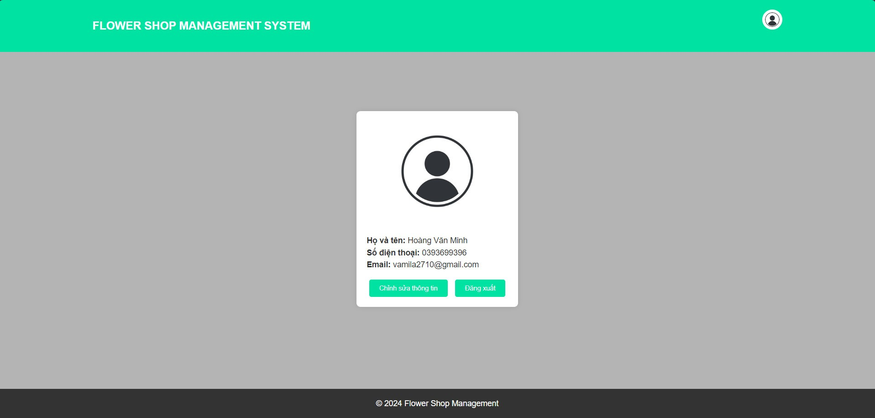

# Home page:

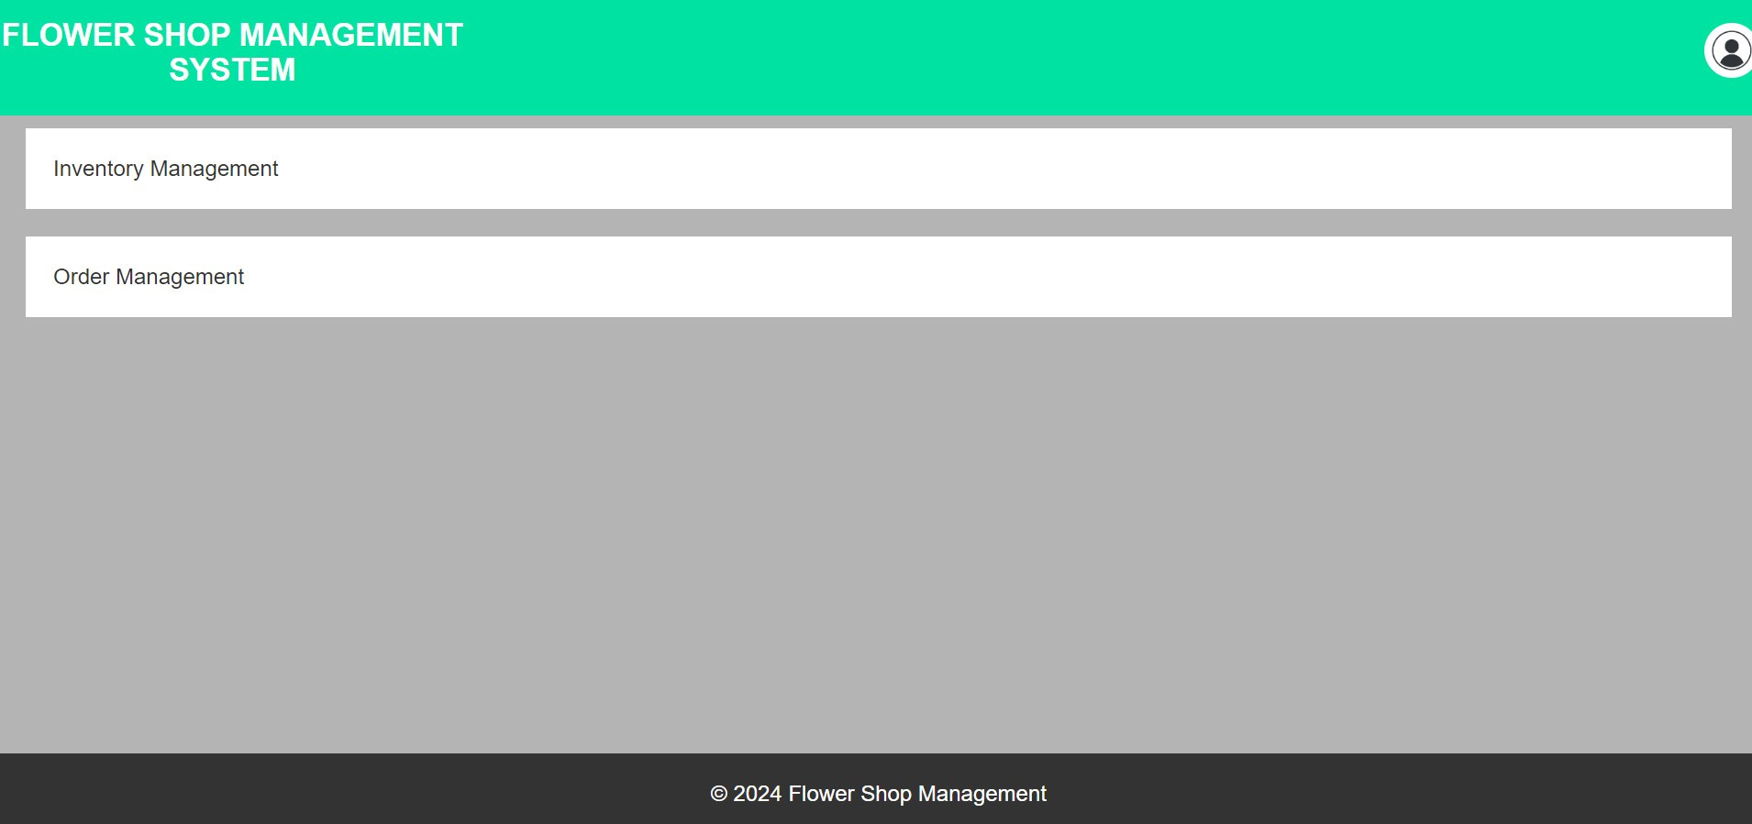

# Manage products:

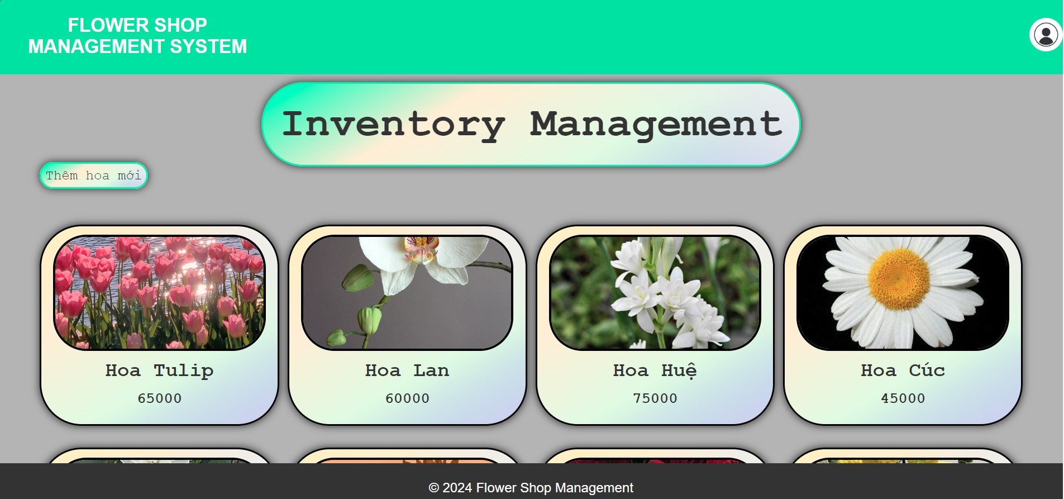

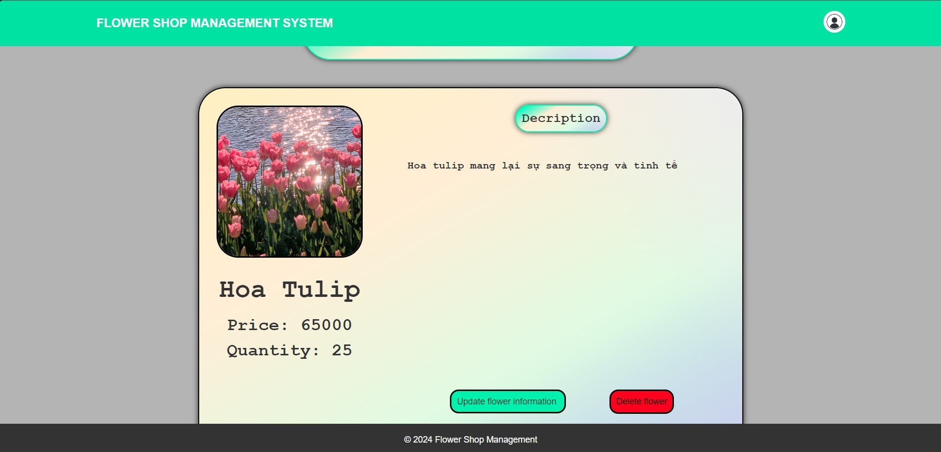

# Manage orders:

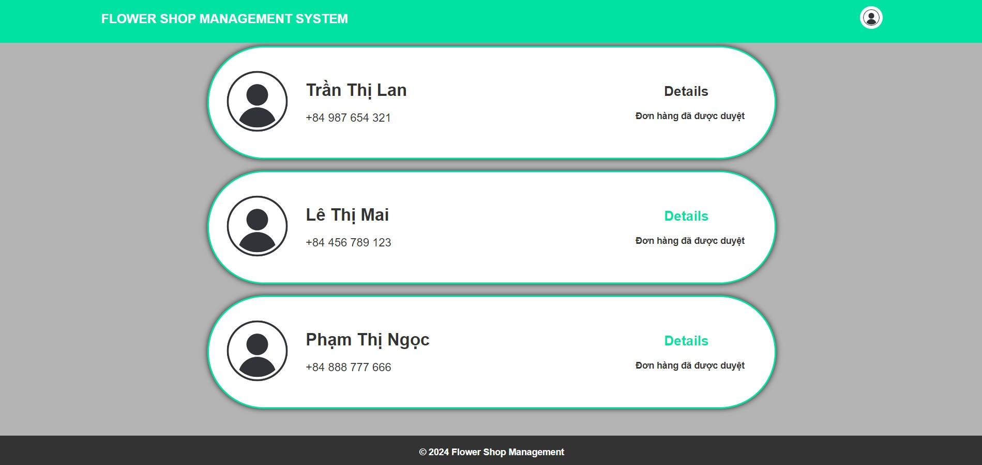

# PART 5: EVALUATION AND CONCLUSION

## 5.1. Advantages:

* Plenty of resources are available for reference, and team members are proactive in searching for relevant documents to support the report.
* Lecturers deliver their teachings in a clear and understandable manner, actively contributing ideas for the group's tasks, and pointing out any mistakes the group may make.
* Each team member demonstrates a strong sense of responsibility.
* There's a culture of mutual support and assistance among group members.

## 5.2. Difficulties:

* Due to lack of experience in group work, members occasionally struggle to grasp each other's ideas.
* Unreliable network connectivity hampers both attending lectures and collaborating effectively within the group.
* The subject matter is extensive and intricate, demanding each member to thoroughly comprehend related topics.
* There's a lack of well-structured time allocation and scheduling between subjects.
* Time is wasted rectifying syntax errors stemming from insufficient consultation of the slides.

## 5.3. Lessons:

* Prioritize Communication Skills: Since team members may lack experience in group settings, prioritizing communication skills training can help improve understanding and collaboration.
* Address Technical Challenges: Given the impact of unstable network connections, it's crucial to address technical challenges proactively to ensure smooth communication and collaboration.
* Emphasize Comprehensive Understanding: The complexity of the subject matter underscores the importance of thorough comprehension. Providing resources and support to help members grasp related topics can enhance overall performance.
* Implement Effective Time Management: Establishing reasonable time allocation and scheduling between subjects can prevent inefficiencies and maximize productivity.

# REFERENCES

1. Lecture slides for Design Analysis and Requirements subject by lecturer Hồ Thị Thanh Tuyến.